Pet Care

# An app to take care of your dog.

1. Find dog dates in your area
2. Find vets in your area
3. Find baby (dog) sitters in your locality.

Menu options :

1. Match/
2. find/
3. feed/
4. service
5. /profile

# High level use case:

* Create a web site, desktop at this moment, mobile and tabs to follow later.
* Number of users 1000.
* Use AWS for hosting application, at this point a free account with just one server would suffice.
* Backend of the system can be a Database like my sql where the user information is stored.

It would be owner’s information at this point, with address and contact details.

* Front end can be react, system can be REST api designed in Java.
* User can adopt a pet => additional feature
* Services => additional feature
* We can show relevant matches for a user==How to find a match.
  + Match can be found using like or dislike-if both users like each other then trigger a mail for match.

# Database Design

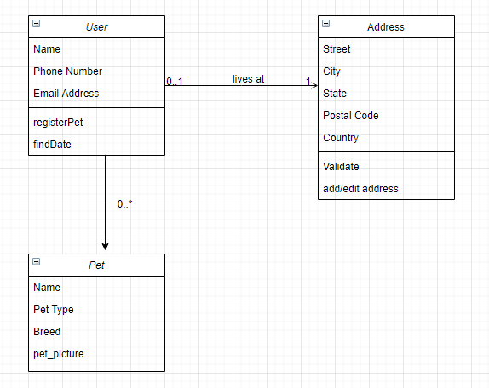

Add like for pets as well as user.

# Additional features but important:

1. Schedule a date(calendar date time)
2. Send a message to owner.
3. Like
4. Comment on picture